COMP3331 Assignment 1

Name : Lean Lynn Oh

zID: z5144464

# STP protocol implementation details

* STP Protocol is implemented in python 3.6.5 and consist 3 modules; sender.py, receiver.py and stp_packet.py. There are 4 classess in total in my program: Sender, Receiver, Timeout and STPPacket.
* STP protocol is implemented with single thread. Hence, the output is slightly different from the sample log but it behaves the same.

## Structure of the program

* sender.py includes the following:
  + Sender class: in charge of connection establishment, connection termination, read file, calculate file size, create payload with size of mss, write to log file, send packet and receive packet. The pld module (in sender class) is used to emulate events that may occur such as packet loss, delays, reorder packet, corrupt packet and send duplicate packet.
  + Timeout class: to calculate timeout interval and store current timeout interval
* receiver.py includes receiver class: in charge of connection establishment, connection termination, write to log file, write received data to file, receive packet and send packet.
* stp_packet.py includes the followings:
  + STPPacket class: the packet structure. My STP packet includes payload, sequence number, ack number, checksum and booleans such as ack, syn and fin.
  + Additional functions for manipulating the packet
    - checksum: calculate the checksum of payload in a packet at the sender
    - corrupt: corrupt the payload in a packet by flipping 1 bit
    - receiver_checksum function: calculate the checksum of payload in a packet at the receiver.

## Sender’s features and its implementations

1. **3 way handshake** for connection establishment is implemented in handshake in sender.py. Sender sends SYN, receive SYNACK and send ACK. During the 3 way handshake, sender updates its states (closed, syn sent and established) accordingly. In the syn sent state, the sequence number and acknowledgment number is incremented by 1.
2. **4 segment connection** termination is implemented in close_connection in sender.py. Sender sends FIN when it has received the ack for the last packet. At this point, it would not send any delayed packets. Sender receive ACK and FIN from receiver and send ACK to acknowledge the fin packet. The sender updates its states (end, fin wait 1, fin wait 2, time wait and closed) accordingly. In the end state, the sequence number is incremented by 1. In the fin wait 2 state, the ack number is the sequence number of received fin incremented by 1.
3. Sender implements the event loop in Figure 3.33 (pg. 273) in the textbook.
4. Sender uses the concepts of sequence number, acknowledge number and flags(ACK, FIN, SYN) in its STP header.
5. In process_data, sender open the file with given filename and read its contents in bytes. Then, it **splits the data into MSS size** and stores them in a list. Sender also calculate the total file size in calc_total_payload for logging purposes.
6. To send a packet, sender **checks for any space in the current window** ( last byte sent – last byte acked <= mws) and **check for any unsend bytes** (last byte sent < file size). If there is any unsend bytes, the sender will **create a packet** with the correct payload from the list (self.contents) and **add it to the packet buffer**. The sender will send as many packets as possible without exceeding MWS bytes. The sequence number of the next packet is incremented with the current payload length. This packet is then **send to the pld** module. If the timer isn’t start yet, the sender will **start the timer**.
7. Sender maintain **a single timer** for timeout operation. The RTO timer is always place at the **send base** (smallest unacknowledged packet in the window). For the **initial timeout** (when send base = 1), the **estRTT and DevRTT** are initiated to **500ms** and **250ms** respectively and calculated with the timeout interval formula. Upon receiving an ack for not retransmitted packet and the packet is at the send base, the sender will calculate the sampleRTT by taking the difference between the send time and the receive time. Then, this is pass to calc_timeout in the Timeout class to calculate the timeout with the following fomulas:

**estRTT = (1 – alpha) * estRTT + alpha*sampleRTT**

**devRTT = (1- beta)*devRTT + beta*abs(sampleRTT – estRTT)**

**timeout = (estRTT + gamma * devRTT) / 1000**

*alpha = 0.125 , beta = 0.25, gamma = user input

Retransmitted packet will not take into account for timeout interval calculation.

1. The STP sender implements **cumulative acknowledgements** as it acknowledges all previously send packet with sequence number smaller than currently received ack number. Current acknowledge number will be the new send base. The sender will remove all acknowledged packets from the packet buffer. If there are packets remaining in the buffer, the sender will start the timer.
2. Upon receiving a duplicate ack, the sender will increment the dup_num counter. The dup_num counter keeps track of the number of ack received with the same ack number. Once the sender had received 3 duplicate acks, the sender will carried out **fast retransmission** by retransmitting the smallest unacknowledged packet.
3. **Timeout transmission** is implemented in sender. It is manually calculated by comparing the send time of the smallest unacknowledged packet and the current time during socket timeout. Socket timeout is set to 0.1. If the time difference is larger or equal to the timeout, the sender will retransmit this packet.
4. The **pld module** is implemented with pseudorandom number generator to determine the condition a packet has to go through. I have initialise the random number generator with a seed value and used random.random() to generate a random number. The probability of an occurrence for a condition is supplied with user input probability. The condition are as the following:
   1. Drop packet: drop a packet if the random number is less than pDrop
   2. Duplicate packet: send 2 back to back packets if the random number is less than pDuplicate and the packet isn’t dropped.
   3. Corrupt packet: corrupt a packet by flipping a bit if the random number is less than pCorrupt and the packet isn’t dropped and duplicated
   4. Order packet: order a packet if the random number is less than pOrder and the packet isn’t dropped, duplicated or corruped. Also, there isn’t any packet waiting for reordering.
   5. Delay packet: delay a packet if the random number is less than pDelay and the packet isn’t dropped, duplicated, corrupted or reordered.
   6. Send a packet without error: send the packet if all the conditions in a-e are not fulfilled.
5. The sender **update Sender_log.txt** with the information about each packet it sends and receives. At the end of execution, the sender updates the required statistics in the assignment specification to the log file.

## Receiver’s features and its implementation

1. **3 ways handshake** for connection establishment is implemented in handshake in receiver.py. Receiver receives SYN, send SYNACK and receive ACK. Receivers updates its states(listen, SYN receive, established) accordingly. Receiver’s ack number and seq number are incremented by 1 upon receiving a SYN.
2. **4 segment connection termination** is implemented in close in receiver.py. Receiver receives FIN, sends FIN, sends ACK and receives ACK. Receiver updates its states (closed wait, last ack, closed) accordingly. The seq number and ack number is incremented by 1.
3. Receiver uses the concepts of **sequence number, acknowledge number** and flags(ACK, FIN, SYN) in its STP header. The acknowledge number will be incremented by the length of the payload in the STP segment.
4. Receiver sends ack upon receiving a packet. If the packet is out of order, receiver stores it in a **buffer** and sends a duplicate ack. If the packet is in order, the receiver will fill the gap, remove the correct packet out of the buffer and sends an ack. Receiver uses cumulative ack. If the receiver receives a corrupted packet, the receiver will drop it without sending a duplicate ack.
5. After the receiver has received the complete file, it will write the bytes into a file.
6. The receiver updates Receiver_log.txt with the information about each packet it sends and receivers. At the end of execution, the receiver updates the required statistics in the assignment specification to the log file.

# STP header

## Structure of STP header

The following is the structure of my STP header:

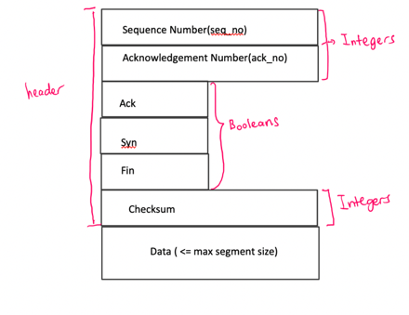

## Explanation of all fields

* Sequence number (seq_no): the sequence number of a packet. It is used to identify the first byte of the payload in a packet. Both sender and receiver use this number to track the packet they are up to sending and acknowledging respectively.
* Acknowledge number (ack_no): the acknowledge number of a packet. It is used to identify the next expected byte. Receiver use this number to check if a packet is out of order and to inform sender the next byte it is supposed to send.
* ack: a boolean to indicate an ack packet, used for acknowledging a received packet
* fin: a boolean to indicate a fin packet, used for connection termination.
* syn: a boolean to indicate a syn packet, used for connection establishment.
* Checksum: used for error detection. Receiver calculates the checksum of the payload value and compare it with this number. If it matches, the payload is not corrupted.

# Design trade-offs and possible improvement

I tried to implement STP protocol using multithreading but my lack of knowledge in python’s multithreading has caused my program fail to execute properly. Currently, the STP sender and receiver is single threaded. Both sender and receiver implements a blocking single threaded event loop that rotates between sending a packet and receiving a packet. The event loops follows an order of execution. To improve my program, I would use multithreading as it would allow sender to receive and send a packet asynchronously.

Besides, I am calculating the timeout manually every time socket timeout by using the difference between time.time() and the send time of the send base to determine should I retransmit the packet. To improve, I would use python’s Timer object as it would call the retransmission function on timeout automatically.

# Experiment result

The sequence of STP packets observed at the Receiver when pDrop = 0.1, MWS = 500 bytes, MSS = 100 bytes, seed = 100, gamma = 4 is as follows:

0 1 1 101 301 401 501 601 201 701 801 901 1001 1101 1201 1301 1401 1501 1601 1701 1801 1901 2101 2201 2301 2401 2001 2501 2601 2901 3001 2701 2801 3029 3030

The sequence of STP packets observed at the Receiver when pDrop = 0.3, MWS = 500 bytes, MSS = 100 bytes, seed = 100, gamma = 4 is as follows:

0 1 101 201 301 1 501 801 401 1001 601 1101 701 1201 901 1601 1701 1301 1801 1401 1501 2001 2101 2201 2301 1901 2701 2801 2401 2501 3001 2601 2901 3029 3030

From the example above, both sequence number traces start with 0, 1 and ends with 3029, 3030 as these sequence number are used in connection establishment and connection termination. These packets won’t get dropped. When pDrop is 0.3, packet loss occurs earlier as we can see packet 1 is dropped. This is because with higher value of pDrop, we increase the likelihood of a drop. 24 packets are dropped when pDrop = 0.3 as compared to 4 packets are drop when pDrop = 0.1.

In the second sequence, there are more missing sequence numbers in between which indicates those packets with the missing sequence number are dropped. These dropped packets are retransmitted on timeout or fast retransmission (result in appendix). Therefore, the higher the pDrop, the higher the retransmission rate.

|  |  |  |
| --- | --- | --- |
| Gamma value | Overall transfer time | Number of Packets transmitted |
| 2 | 75 minutes 36s | 12652 |
| 4 | 140 minutes 9s | 12450 |
| 6 | 188 minutes 49s | 12450 |

The higher the gamma value, the longer the overall transfer time as the time needed for timeout retransmission increases. For low gamma value(ie. 2), the number of retransmission is higher as there might be pre mature retransmission. For large gamma value (ie. 4 and 6), the number of packets transmitted is the same but the overall transfer time is much higher when gamma value is 6 as the timeout interval is larger. A packet waits longer before retransmission.

The file has been transferred successfully. The STP took 5 minutes and 32 seconds to transmit the file. pDrop is the most critical factor contributing most in the overall time as the number of packets dropped is higher than corrupted packets, duplicate packets and reordered packets. The second most critical factor contributing in the overall time is pCorrupt. Duplicate packets has no effect on the overall time as it will be transmitted immediately to receiver. Reordered packet has little effect on the overall time as the maxOrder is less than the number of packets allowed in the window size, making it being transmitted quite quickly.

Most of the overall time is spend on timeout retransmission and fast retransmission caused by both pDrop and pCorrupt. If sender receive 3 dup acks, it can carry out retransmission which means the time needed to retransmit is much lesser. If the sender isn’t receiving any 3 dup acks, it can only retransmit on timeout which takes much longer.

# Appendix

Part a

1. Receiver log for pDrop = 0.1, MWS = 500 bytes, MSS = 100 bytes, seed = 100, gamma = 4

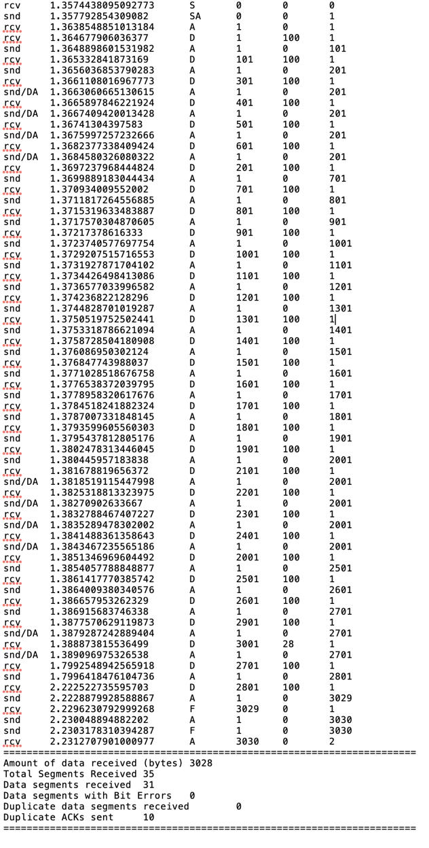

1. Receiver log for pDrop = 0.3, MWS = 500 bytes, MSS = 100 bytes, seed = 100, gamma = 4

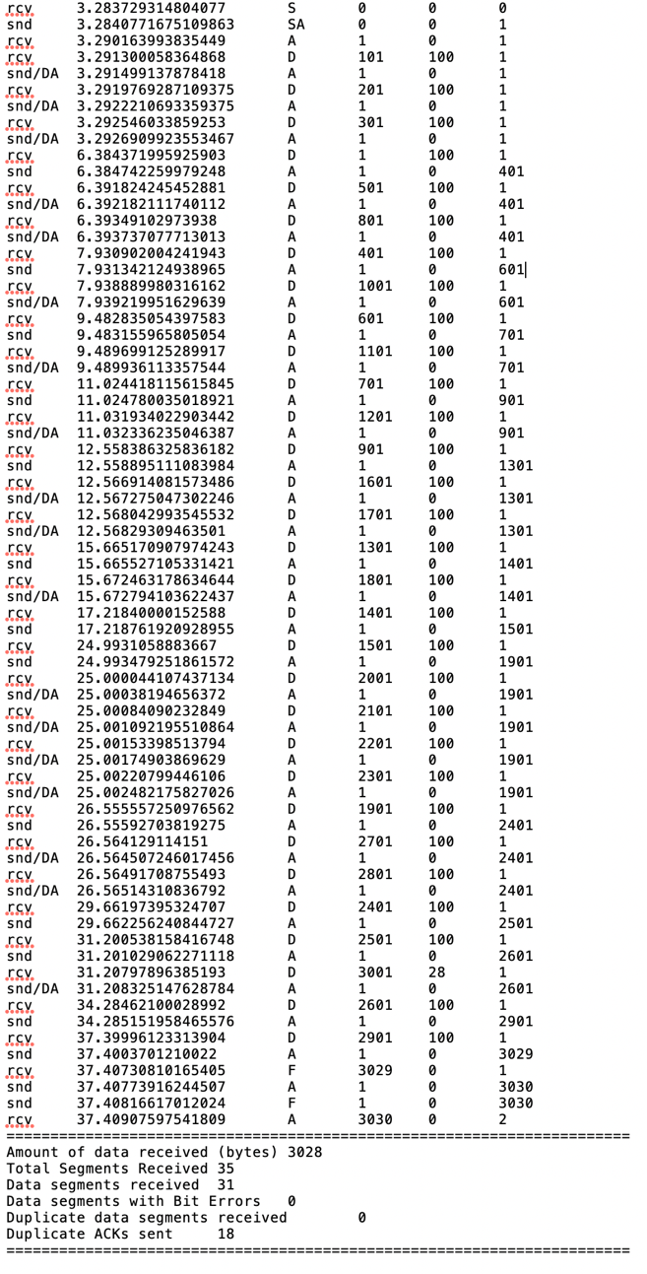

Part b

1. Receiver log when gamma value = 2

First 23 entries

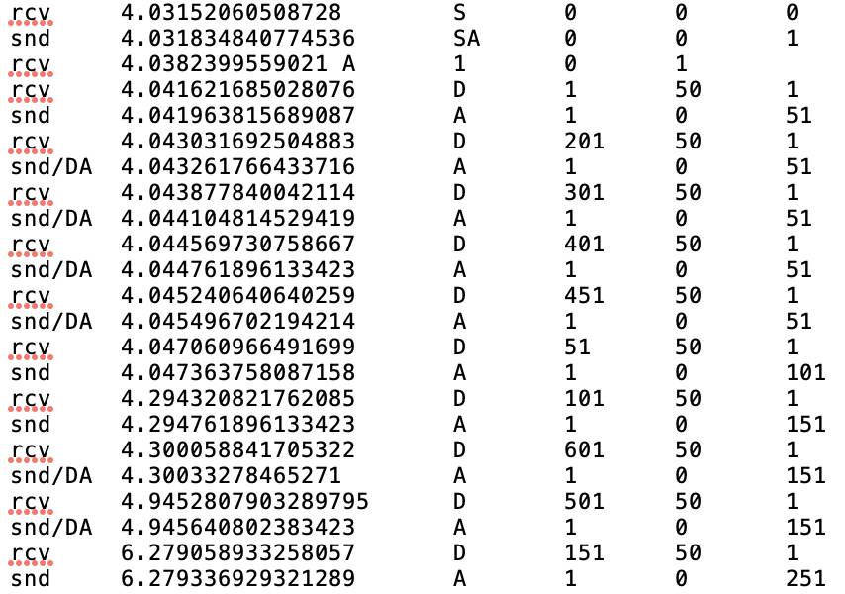

Last 24 entries

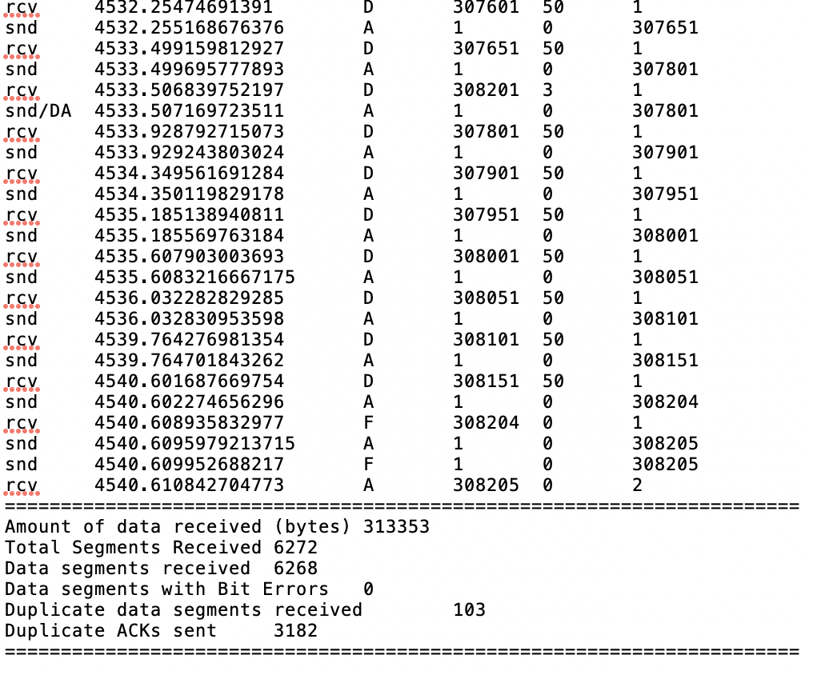

Sender log when gamma value = 2

First 23 entries

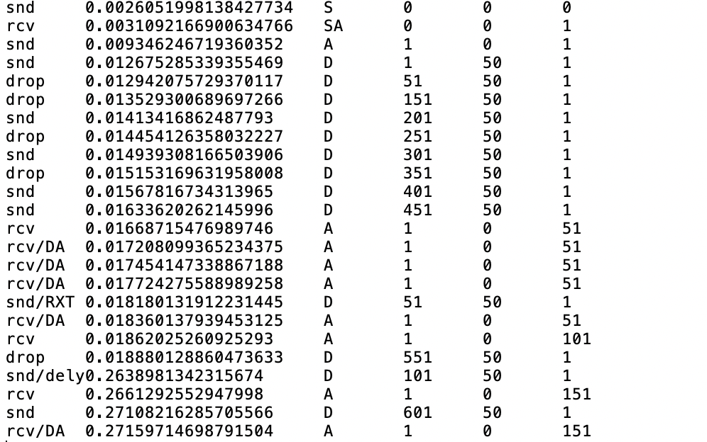

Last 24 entries

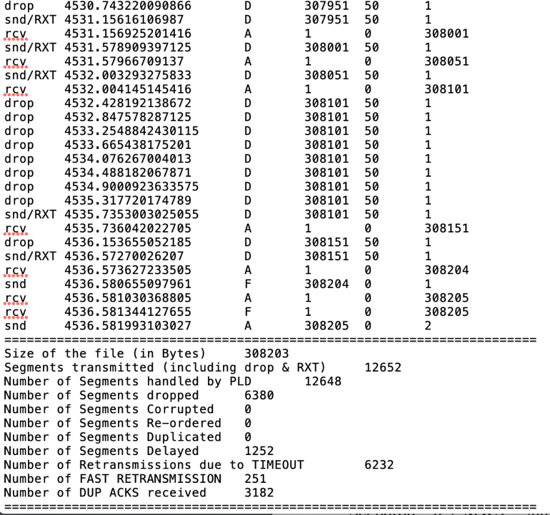

1. Receiver log when gamma value = 4

First 23 entries

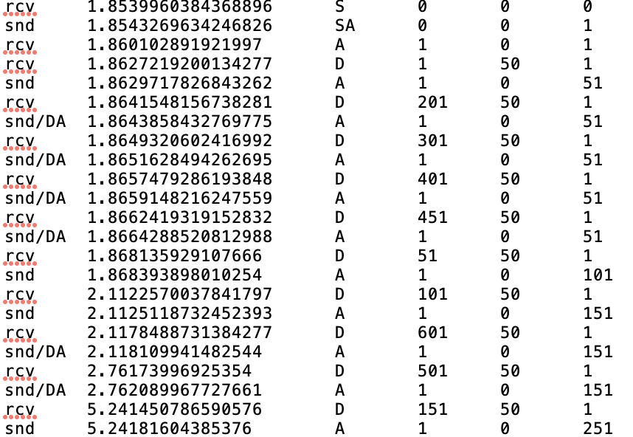

Last 24 entries

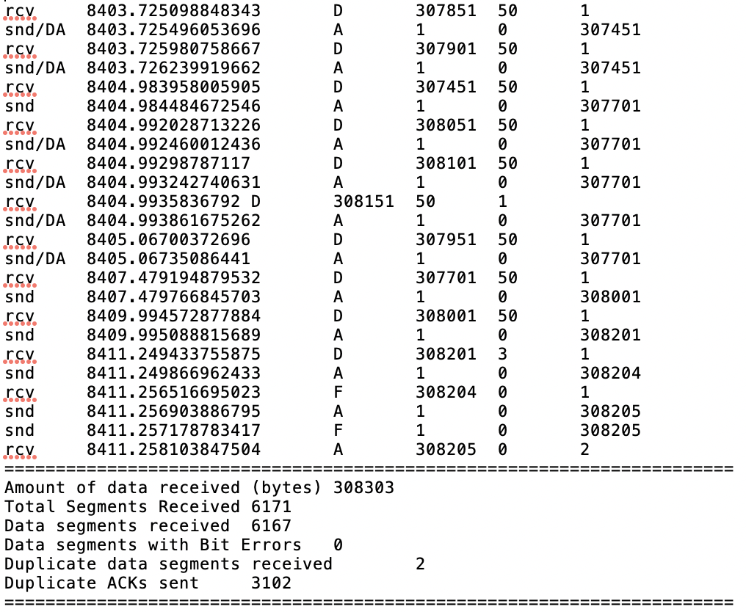

Sender log when gamma value = 4

First 23 entries

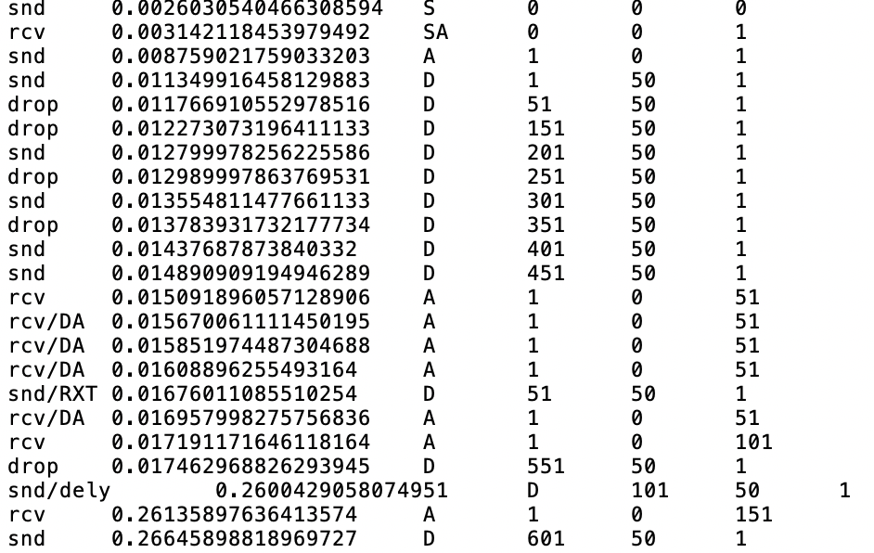

Last 24 entries

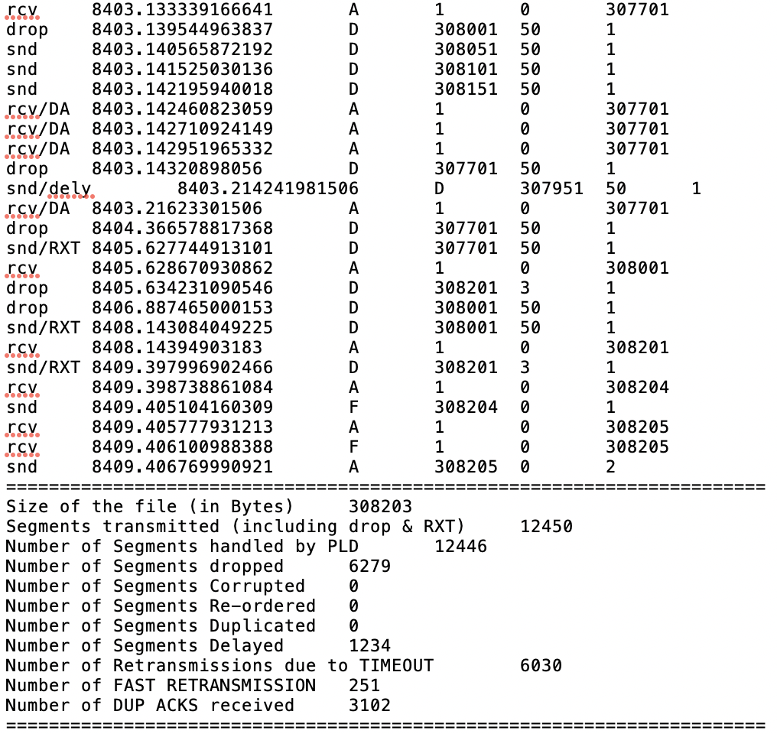

1. Receiver log when gamma value = 6

First 23 entries

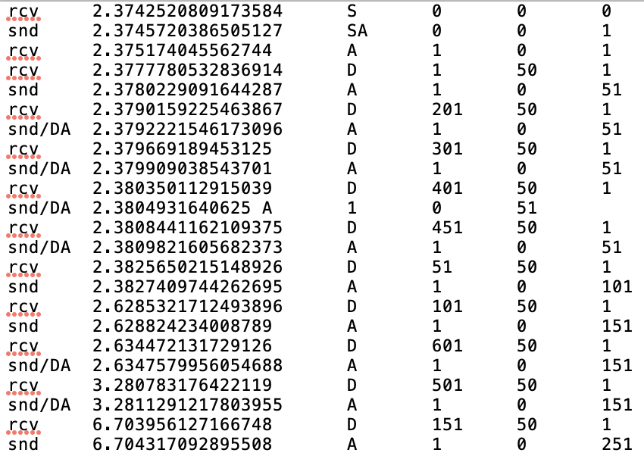

Last 24 entries

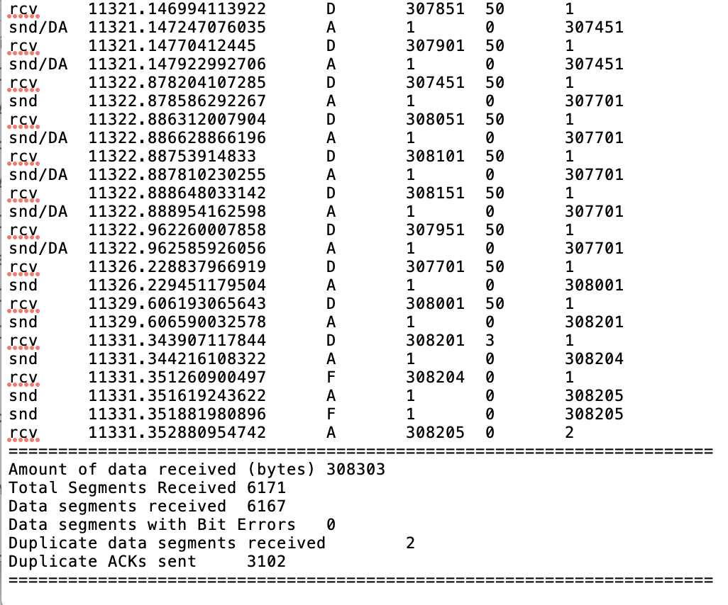

Sender log when gamma value = 6

First 23 entries

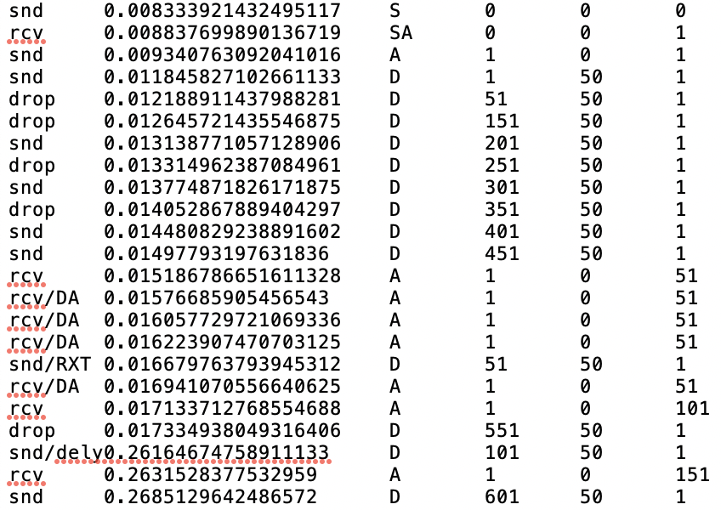

Las 24 entries

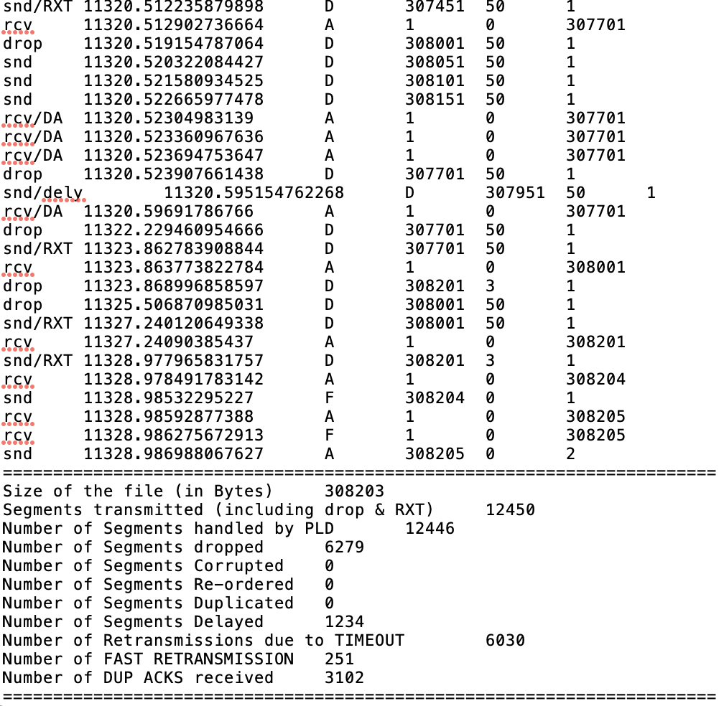

Part c

Receiver log for MWS=500bytes MSS=50 gamma=4 pDrop=0.1 pDuplicate=0.1 pCorrupt=0.1 pOrder=0.1 maxOrder=4 pDelay=0 maxDelay=0 seed=300

First 23 entries

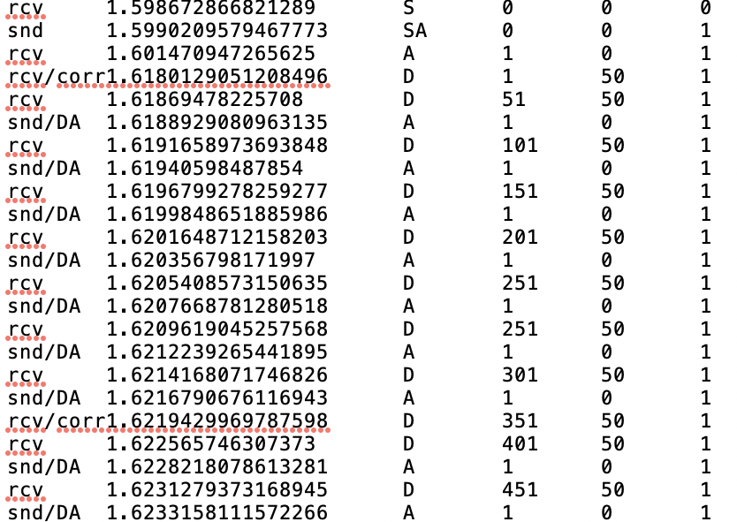

Last 24 entries

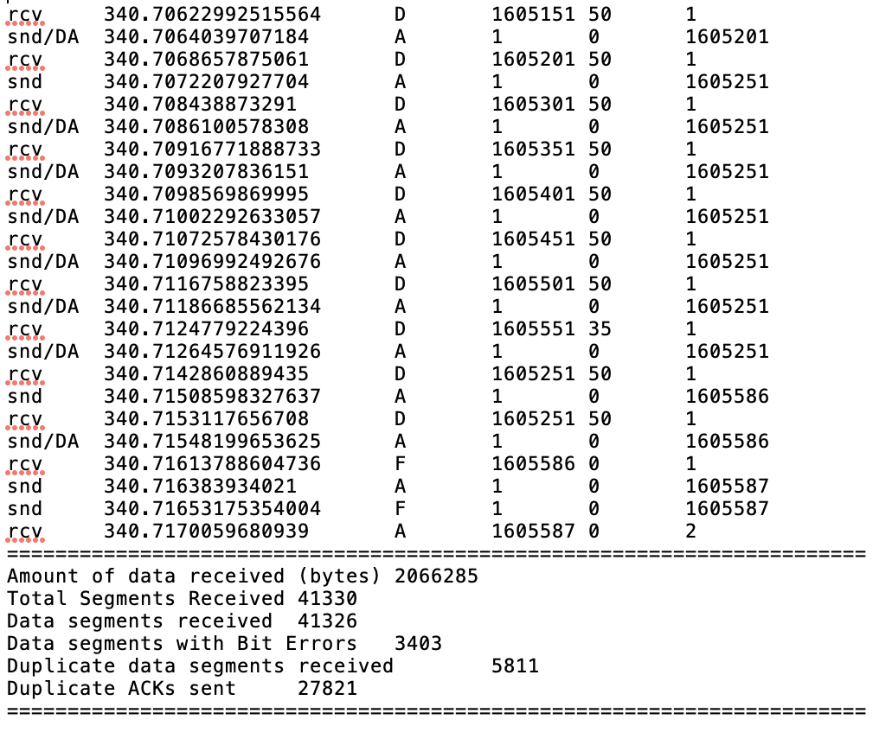

Sender log for MWS=500bytes MSS=50 gamma=4 pDrop=0.1 pDuplicate=0.1 pCorrupt=0.1 pOrder=0.1 maxOrder=4 pDelay=0 maxDelay=0 seed=300

First 23 entries

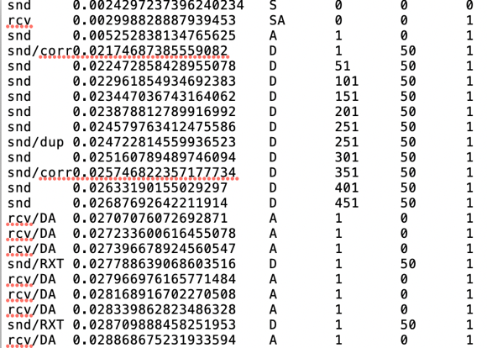

Last 24 entries

